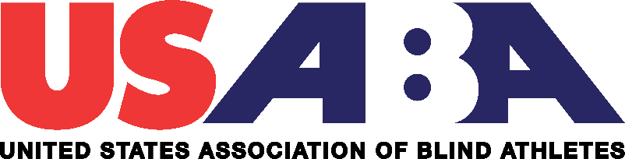

United States Association of Blind Athletes (USABA)

Board of Directors Meeting Tele-Conference Call

August 22, 2019

Directors present: Gary Remensnyder, Amy Wasson, Paul Shields, Larry Dickerson, Brittany Wozny

Absent: Michael Bina, Matt Simpson

Staff present: Mark Lucas, Kevin Brousard

The meeting of the Board of Directors was called to order at 9:03 a.m. MST by vice-president Larry Dickerson who presided for absent chair Michael Bina.

A motion was made to approve the May 30, 2019, board meeting minutes. A seconded was made to the motion and there being no objections, the motion was passed.

Chairman’s Report

No chairman’s report was provided.

Executive Director Report

Reported by Mark Lucas, Executive Director

Mark gave a summary of the 2019 IBSA International Goalball & Judo Qualifying Event that took place in Fort Wayne, IN in July. The combined participation for the goalball, judo and General Assembly was more than 600 delegates from 43 countries. Turnstone, serving as the fiduciary party for the event, is closing the books on the event and they will have the final budget in September. Mark mentioned numerous benefits to USABA for co-hosting this event in the USA including the goalball teams not having to travel overseas and having the opportunity to compete on their home floor in Fort Wayne.

Mark stated that this week, both the Men’s and Women’s National Goalball Teams arrived in Lima, Peru, along with Team USA to compete at the 2019 Parapan American Games. The event will serve as the final opportunity for the men’s team to qualify for the 2020 Tokyo Paralympic Games. By virtue of their silver medal performance during the qualifying event in Fort Wayne, the Women’s National Team qualified for Tokyo. New interim head and assistant coaches have been recruited and named for the men’s team. Mark stated that he and Dr. Bina will be in attendance for the Parapan American Games in Lima, Peru, August 24 through September 1.

Mark also reported that recruitment efforts are underway for the second annual National Blind Sports Day taking place October 5th across the U.S. USABA secured a $25,000 title sponsorship from Healthy Vision Association for the event.

Two new donor initiatives were recently unveiled which include the Lasting Vision Society, a planned giving program and the 100 Athletes Program which seeks gifts from active and retired USABA athletes.

USABA was announced as one of 12 finalists for the Robert Wood Johnson Foundation Sports Award which will be determined September 16.

Staff is working on submitting a 3-year grant proposal to the Robert Wood Johnson Foundation to expand programming.

On the programming side, USABA hosted its inaugural Emerging Stars ID Camp at the Colorado Springs U.S. Olympic and Paralympic Training Center from July 21-25 for 20 blind teenagers and 5 coaches.

At the resident goalball homes in Fort Wayne, IN, progress has been made on the excavation project for flood mitigation. An engineer report has been submitted to an excavating company, which is the first step in starting the basement renovation project targeting the women’s house.

Mark concluded his report and asked the floor if there were any questions on his report.

Gary Remensnyder asked about the financial implications for the basement renovation. Mark stated that there is currently $120,000 in restricted funds set aside in a bank in Fort Wayne held by the Indiana District Lions for the resident home’s basement project. $45,000 of that came from USABA, $15,000 came from local Indiana Lions Clubs and a $60,000 match was granted from Lions Club International Foundation.

Strategic Planning Committee Report

Report by Larry Dickerson

The committee met August 12, 2019, and the minutes were sent to the board. Larry reports that the programmatic and educational components of the strategic plan are going well citing new initiatives as a key addition. Larry requested that the board members bring new ideas and long-terms goals to the next board meeting. Larry stated that the staff will meet in early October to develop the 2020 Operational Plan and Proposed Budget in preparation for the October 31-November 1 board meeting.

Audit and Finance Report

Report by Gary Remensnyder, treasurer

Gary reported that the Q2 report was very similar to Q1 report, and that we are on track to stay within budget. The projected revenue deficit is $183k which can be explained by a budget timing issue with the way the budget is split up evenly over 12 months. This even split does not sync up with expected revenue timelines and will be addressed in the future with staff.

Through June 30, 2019, the U.S. Olympic Foundation was at $462k, up from $410k starting balance in January 2019.

New Business

Paul Shields asked for an update on board’s progress on the bylaw revisions which we are to submit to the United States Olympic and Paralympic Committee (USOPC) to become a Paralympic Sport Organization (PSO). Brittany Wozny responded that she and Matt Simpson were working together on the latest draft and they expect to submit it to the full board within two weeks. Brittany Wozny stated she is taking the lead on making any final edits before submission.

Larry asked about appointing new board members. Paul mentioned this has been delayed until we submit our bylaw revisions to the USOPC to get approval on our PSO membership approval. A discussion ensued about board term lengths.

Mark informed the board that USABA will undergo a USOPC audit in September overviewing best practices which includes governance, athlete safety and financials.

Gary asked about location of the next board meeting, and Mark confirmed it will be held in Colorado Springs from October 30-November 1, 2019.

Adjournment

Amy Wasson motioned to adjourn. The motion was seconded. There being no objections, the meeting was adjourned at 9:57 am MST.