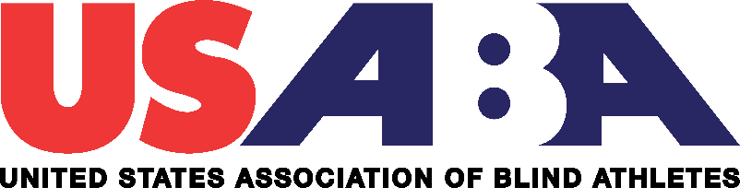

**JOB ANNOUNCEMENT**

**Position Title:** Goalball Coordinator

**Posting Dates:** October 17-30, 2019

The United States Association of Blind Athletes (USABA) seeks to hire a dynamic individual with impeccable character and organizational skills to serve as the High-Performance Coordinator for the U.S. Men’s and Women’s National Goalball programs. This individual’s purpose will be to support the well-being of goalball athletes in achieving sustained competitive excellence and preserve the Paralympic principles by representing the United States Olympic and Paralympic Committee (USOPC) and the United States Association of Blind Athletes (USABA).

**Brief Overview of the Organization**

USABA is unique within the sports community. As the member organization of the USOPC, USABA is the High-Performance Management Organization (HPMO) for the sport of goalball. As an organization, we develop all aspects of the sport of Goalball from grassroots to elite teams with consistent medal-winning performances at elite international competitions and highly-trained coaches who represent our country both on and off the field of play.

**Mission**

The United States Association of Blind Athletes empowers Americans who are blind and visually impaired to experience life-changing opportunities in sports, recreation and physical activities, thereby educating and inspiring the nation.

**Our Vision**

Every American who is blind or visually impaired will lead a healthy lifestyle by actively participating in sports, recreation and physical activity.

# **History**

# Since its founding in 1976, the USABA has reached more than 100,000 blind and visually impaired individuals. During that time, the organization has emerged as more than just a world-class trainer of blind athletes. It has become a vocal champion of the abilities of America's legally blind residents.

**Minimum Qualifications Required:**

|  |  |
| --- | --- |
|  |  |
| * Bachelor’s degree is preferred but not required. | |
|  |  |
|  |  |
|  | |
|  |  |
| **Experience:** |  |
| * Minimum 1-2 years of experience in sports management with a proven track record of success * Experience working independently * Experience in planning and organization | |
|  |  |
| **Skills and Competencies:** |  |
| * Strong organizational skills * Have exceptional interpersonal and communication skills, both written and verbal * Strong computer skills   **Additional Requirements:**   * Successful completion of a favorable background check * Successful completion of the U.S. Safe Sport on-line training class * Successful completion of the Center for Disease Control on-line concussion class | |
|  |  |
| **Conditions** |  |
| * Incumbent must be flexible with their schedule as work on weekends, some holidays may also be required. National travel will be required. | |
|  |  |
| **Compensation** |  |
| This is a part-time, contracted position with compensation to commensurate with experience. | |

**To apply**

Interested parties should email a cover letter and resume no later than October 30, 2019 to: Mark Lucas; Executive Director at [mlucas@usaba.org](mailto:mlucas@usaba.org). In the subject line of the email write Goalball Coordinator position.

For more information on USABA, go to our web site at [www.usaba.org](http://www.usaba.org).

**JOB DESCRIPTION**

**Position Title:** Goalball Coordinator

**Reports to:** Jake Czechowski and Keith Young: Women’s and Men’s Goalball Head Coaches and High-Performance Managers

**Position Summary:** Major Responsibilities include;

* To support the head coaches in planning and the administration of implementing a robust goalball program.

**Major Duties**

* Manage policies, procedures, administration and schedule of USABA domestic goalball season;
* Monitor and track goalball teams and goalball athletes that are registered with USABA;
* Track, monitor and confirm that all coaches and relevant individuals have completed SafeSport, Background Check, and Concussion Training;
* Ensure that all athletes, coaches and officials have completed their membership with USABA before attending sanctioned tournaments;
* Coordinate with head of officials the scheduling of goalball officials for each tournament and oversee official’s recruitment and development;
* Partner with National Team Coaches to develop and oversee regional club goalball development;
* Partner with National Team Coaches to develop and oversee national goalball recruitment program;
* Book travel for approved coaches and officials to attend regional and national tournaments.

**Work Conditions:**

* Position is part-time and requires non-traditional work hours
* Some travel to goalball tournaments is required
* Expenses will be reimbursed on all approved travel.

**Duties as assigned**

*Further duties can be assigned by Head Coaches.*

**USABA Policies and Procedures**

*Staff are required to follow all policies and procedures of USABA (refer to Employee Handbook).*

**Performance Evaluation**

*An annual evaluation by the Head Coaches will occur.*