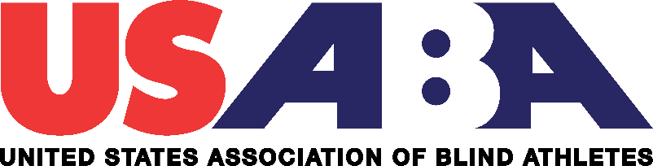

**JOB ANNOUNCEMENT**

**Position Title:** Membership & SafeSport Coordinator

**Posting Dates:** November 9- December 4, 2019

The major responsibilities of the Membership & SafeSport Coordinator include, but are not limited to, planning and implementation of sports programming and events, developing and implementing specific, targeted initiatives to maintain and increase membership, cultivating an outreach network by establishing good working relationships with community-based partners, coordinating USABA’s SafeSport and safety initiatives and providing administrative and logistical management for events, programs and organizational duties.

**Brief Overview of Organization**

USABA is unique within the sports community. As a member organization of the USOPC, USABA is the High-Performance Management Organization (HPMO) for the sport of goalball and a Multi-Sport Organization (MSO) providing programming in numerous sports and physical activities for Americans who are blind and visually impaired.

**Mission**

The United States Association of Blind Athletes empowers Americans who are blind and visually impaired to experience life-changing opportunities in sports, recreation and physical activities, thereby educating and inspiring the nation.

**Our Vision**

Every American who is blind or visually impaired will lead a healthy lifestyle by actively participating in sports, recreation and physical activity.

# **History**

# Since its founding in 1976, the USABA has reached more than 100,000 blind and visually impaired individuals. During that time, the organization has emerged as more than just a world-class trainer of blind athletes. It has become a vocal champion of the abilities of America's legally blind residents.

**Minimum Qualifications Required:**

|  |  |
| --- | --- |
| **Education:** |  |
| * Bachelor’s degree is preferred. | |
|  |  |
|  |  |
|  | |
|  |  |
| **Experience:** |  |
| * Minimum of 2 years of experience in adaptive sports programs or sport management background * Experience working independently * Experience in planning and organization | |
|  |  |
| **Skills:** |  |
| * Ability to build and nurture key professional relationships * Experience with database management * Possess exceptional interpersonal and communication skills, both written and verbal * Must be proficient in Microsoft Office programs * Ability to multi-task, handle frequent interruptions and competing priorities, be good at time management and meet deadlines * Self-motivated and able to work independently and as part of a team * Strong awareness of self and self-regulation * Must be flexible and approachable with a positive attitude * Ability to thrive and willingness to work in a pressured environment with irregular and long hours * Driven by achieving results and a passion to succeed   **Additional Requirements:**   * Successful completion of a favorable background check * Successful completion of the U.S. SafeSport on-line training class * Successful completion of the Center for Disease Control on-line concussion class | |
|  |  |
| **Conditions** |  |
| * Incumbent must work out of the USABA national office located in Colorado Springs, Colo. Incumbent must be flexible with their schedule as work on weekends and some holidays may also be required. National travel will be required. | |
|  |  |
| **Salary Range:** |  |
| $32,000 to $34,000 a year. Benefits include health insurance, 403(b) retirement plan, sick leave  and vacation. | |

**To apply**

Interested parties should email a cover letter and resume no later than December 4, 2019, to: Mark Lucas, Executive Director, at [mlucas@usaba.org](mailto:mlucas@usaba.org) and Kevin Brousard, Programs and Finance Manager at [kbrousard@usaba.org](mailto:kbrousard@usaba.org) . In the subject line of the email write “Membership Coordinator Position”.

For more information on USABA, go to our website at [www.usaba.org](http://www.usaba.org).

**JOB DESCRIPTION**

**Position Title:** Membership & SafeSport Coordinator

**Reports to:** Kevin Brousard, Programs and Finance Manager

**Position Summary:** Major responsibilities include;

* Plan, implement and evaluate sports programming and events.
* Develop and implement specific, targeted initiatives to maintain and increase membership.
* Provide membership with timely, informative, and high-quality customer service.
* Establish, communicate and maintain relationships with our members to keep them interested and satisfied with USABA’s benefits and programs.
* Coordinate administrative and logistical duties for events, training camps and grant programs.
* Speak on behalf of the organization at meetings, conferences, and special events.
* Cultivate an outreach network by establishing good working relationships with the program director and our key constituent groups, including USABA Sports Clubs, agencies that serve the blind and visually impaired, National Governing Bodies, U.S. Paralympics, Paralympic sports clubs, multi-sport organizations, teacher’s for the visually impaired, etc.
* Administrative duties, including but not limited to: tracking of relevant SafeSport training, background checks and concussion protocols; membership for USABA sanctioned events and more.
* Management of USABA online store, including inventory checks and shipping duties.
* Maintain, manage and build existing and new USABA Sports Clubs with the goal of increasing membership through effective partnerships.
* Assist organization in efforts to increase revenue through fundraising and membership initiatives.
* Organize and implement local sports programming.
* Other duties as assigned.