**Anthem Foundation/USABA National Fitness Challenge**

**Tracking impressions on Facebook and Twitter**

**Facebook –** We need FIVE pieces of information on each post you share on your Facebook page surrounding the NFC: impressions, direct link, likes, comments and shares.

1. Impressions (or Reach) –

To view reach numbers, your organization must have a Facebook Page (versus be a Facebook user) and the person tracking impressions must be an administrator of the page to view reach. Facebook estimates the reach for each post and lists it between the post text and/or image or link and the “like”, “comment”, and “share” buttons. Unfortunately, this information is not accessible with voiceover technology.

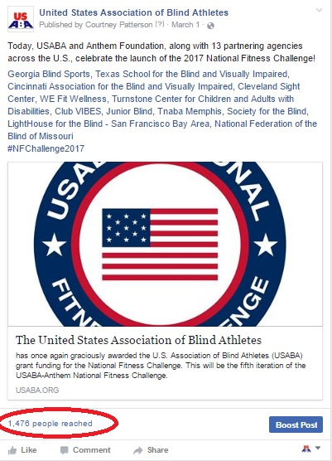

1. Engagement (likes, comments and shares) –

We also want to know how people engaged with the content you shared. You can find total likes, comments are shares directly under the “like”, “comment” and “share” buttons. You don’t have to be an administrator of your page to view this information.

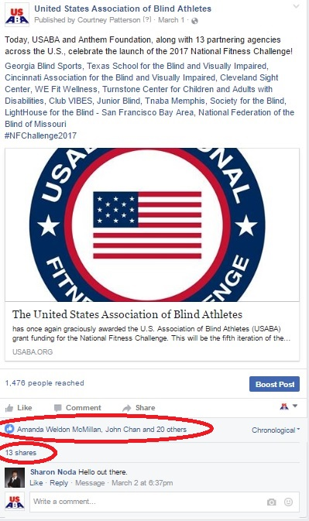

1. Direct link to the post you are referencing –

You can get this unique url by clicking on the time and date the post was shared (next to published by info).

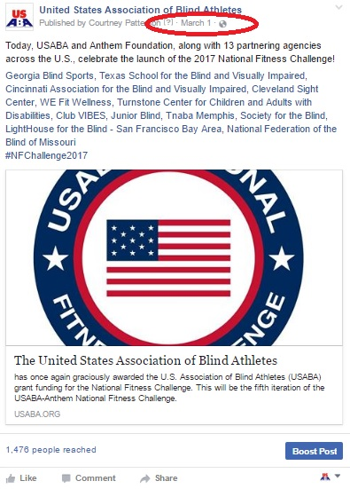

Clicking the time and date of when the post was shared will bring you to a new page where this is the only post listed. Copy the url in your address bar and paste into your tracking document.

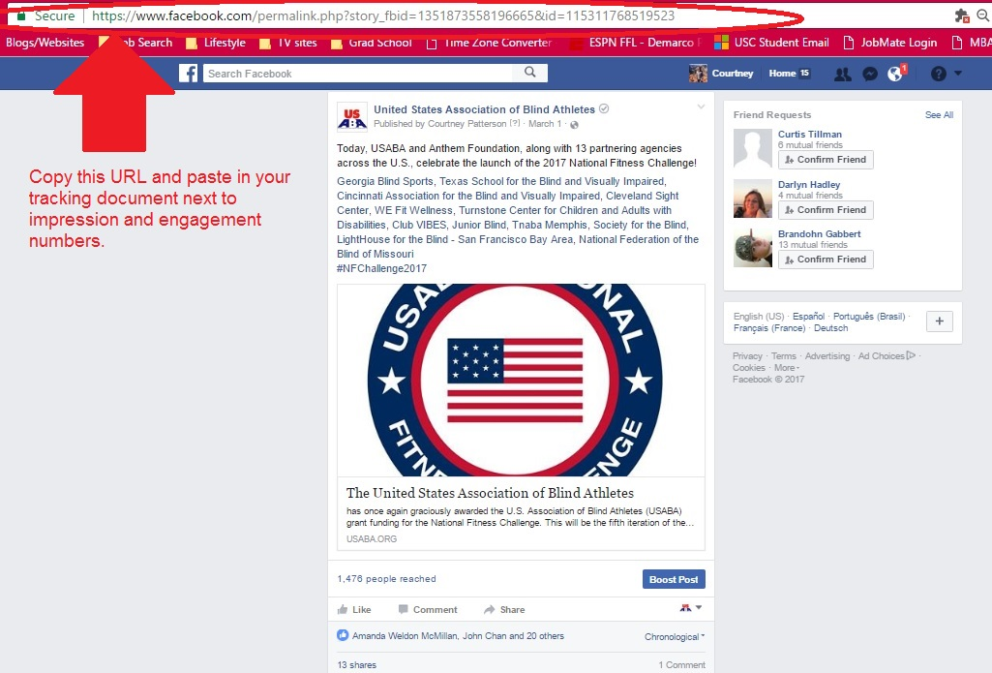

**Twitter** – We need 5 pieces of information on each post you share from your organization’s Twitter handle surrounding the NFC: impressions, direct link, likes, retweets and replies.

1. Impressions (or Reach) –

Like with Facebook, you will also need admin access to your organization’s Twitter handle to view impression numbers for each tweet. To view impressions per post, go to your organization’s twitter page (the one that lists only your tweets).

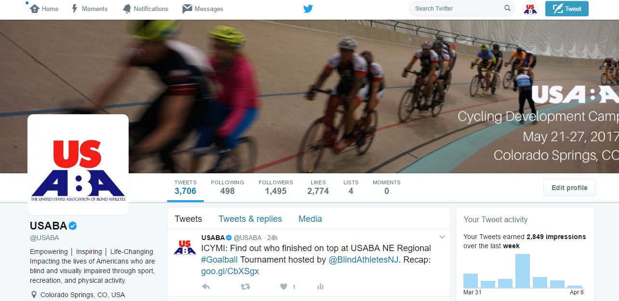

Click on the tweet you want to track. There will be a graph icon after the reply, retweet and heart buttons. Click the graph icon.

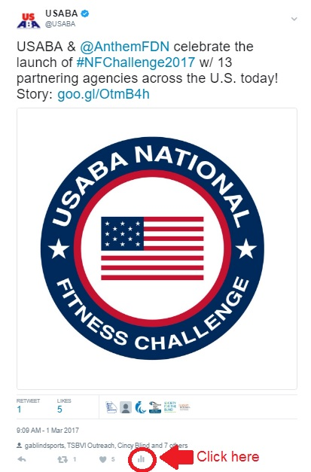

There you will find number of impressions for that tweet. These numbers tend to increase over time so we recommend waiting 2-3 weeks before recording number of impressions for a tweet in your tracking document.

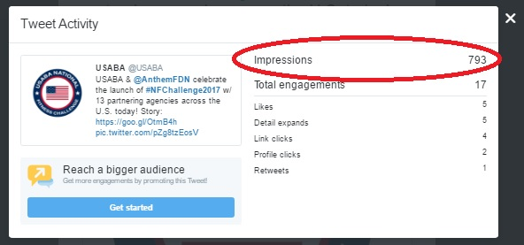

Contact USABA Program Specialist, Tracy Kinoshita, with any questions: [tkinoshita@usaba.org](mailto:tkinoshita@usaba.org).