**Anthem Foundation/USABA National Fitness Challenge**

**Recognition Ideas**

**Press Releases**

A press release is a great way to gain recognition for your organization and raise awareness about your participation in the Anthem/USABA National Fitness Challenge (NFC). Anthem Foundation and USABA will distribute a national press release about the partnership listing your organization sometime in September. You can reference the national release or the *NFC press release template* from the online toolkit (<https://www.usaba.org/nfc2018toolkit/>) to build a local release promoting your agency’s involvement in the initiative. Please note that all press releases must be approved by your local Anthem PR Director, listed at the end of this document, and Tracy Kinoshita before distribution. If you do not have a dedicated PR department or staff member, Tracy can also help write, edit and distribute your press releases. Friendly reminder to use the appropriate Anthem Foundation brand (name and logo) when writing your press releases.

Tip: Utilize established relationships with local media contacts. Has a local news station or publication covered your organization in the past? Reach out to them again and pitch your participation in the Anthem/USABA National Fitness Challenge. If you don’t have established relationships with local media outlets, let us know. We can help you put together pitches and distribute releases.

**Success Stories**

As the program gets going, participants will start to achieve goals – weight loss, more active lifestyles, discovering a new sport, setting new personal records. These success stories – big and small – need to be shared! Consider highlighting success stories by writing an article, posting photos or video on social media or pitching to local media for a human-interest story. Don’t forget to snap some photos to pair with the story!

Tip: When highlighting a participant, make sure they are aware and okay with you highlighting their success.

**Photos**

Photos are a great way to showcase your NFC initiatives. You don’t have to have a photographer on staff to get great photos but it wouldn’t hurt to consider hiring a photographer (even if it’s a friend who might do it for a reduced rate or free) when hosting an event. You’ll likely be tied up with event logistics and unable to watch for photo ops. If you’re unable to hire someone, here are some tips:

* Consider your background. You don’t want a background that’s so busy we don’t know what you were focusing the photo on.
* Consider lighting. If you’re outside/inside, adjust settings accordingly if you’re not using a phone camera.
* Smiling faces! Tell the subject your taking a photo of them (unless you’re trying to snap a candid photo) so they can look towards the sound of your voice and smile.
* Logos! Think about getting the local Anthem Foundation’s logo or the National Fitness Challenge logo in the photo if possible – a banner in the background, logo on a t-shirt or water bottle, etc.
* Keep in mind the [thirds principle](https://www.photographymad.com/pages/view/rule-of-thirds). The rule of thirds involves mentally dividing up your image using 2 horizontal lines and 2 vertical lines. You then position the important elements in your scene along those lines, or at the points where they meet. The idea is that an off-center composition is more pleasing to the eye and looks more natural than one where the subject is placed right in the middle of the frame.
* Periodically send photos (and photo credits if applicable) to Tracy Kinoshita so USABA can also promote your photos on social media and in newsletters.

**Videos**

Videos are another great way to showcase your participants, programs and events. Not all agencies will have the capacity to film and edit videos but if you do, we encourage it! Even a video made on a cell phone can showcase the great work you’re doing through the National Fitness Challenge! Some tips:

* Consider your environment. Think about background, lighting and noise. Like photos, you won’t want a lot going on in the background visually as well as auditorily.
* Sound. If you’re recording a video on your cell phone, without a microphone, do a test to make sure you can hear the subject before you shoot the actual video.
* Center the video. If you’re interviewing a participant, you’ll want to make sure you have their face in the shot – that you’re not cutting off the top of their head for instance.
* Promote the brand. If you’re interviewing a participant, encourage them to mention the National Fitness Challenge and the local Anthem Foundation brand somewhere in the video.
* Send any videos to Tracy Kinoshita so USABA can also promote them on social media and in newsletters.

**Newsletters**

If you have an existing newsletter (print or electronic) that is already scheduled to go out to your member and/or donor database, the Anthem/USABA National Fitness Challenge is a great initiative to highlight. When writing an article about your participation in the NFC, we suggest giving a brief overview of the initiative and its immediate goals and then going into what you’re doing at the local level. It’s fun to highlight events, like your Paralympic Day, or success stories from participants who have made strong progress towards their goal, too.

Tips: Link to an NFC success story on your website or a landing page that gives more information on the National Fitness Challenge if readers want to learn more.

**Social Media**

If your agency is on social media, this is an easy way to boost overall impressions – especially if you have a large following. We ask that you post about your participation in the NFC at least twice a month on your social media accounts. The posts can be photos from a weekly running group, a link to an article you wrote about a participant’s success story, etc. Be sure to tag you local Anthem brand if they have a presence on social media and use the hashtag #AnthemFitnessChallenge so USABA sees it and can share and retweet your posts. Check out some examples of great social posts below.

[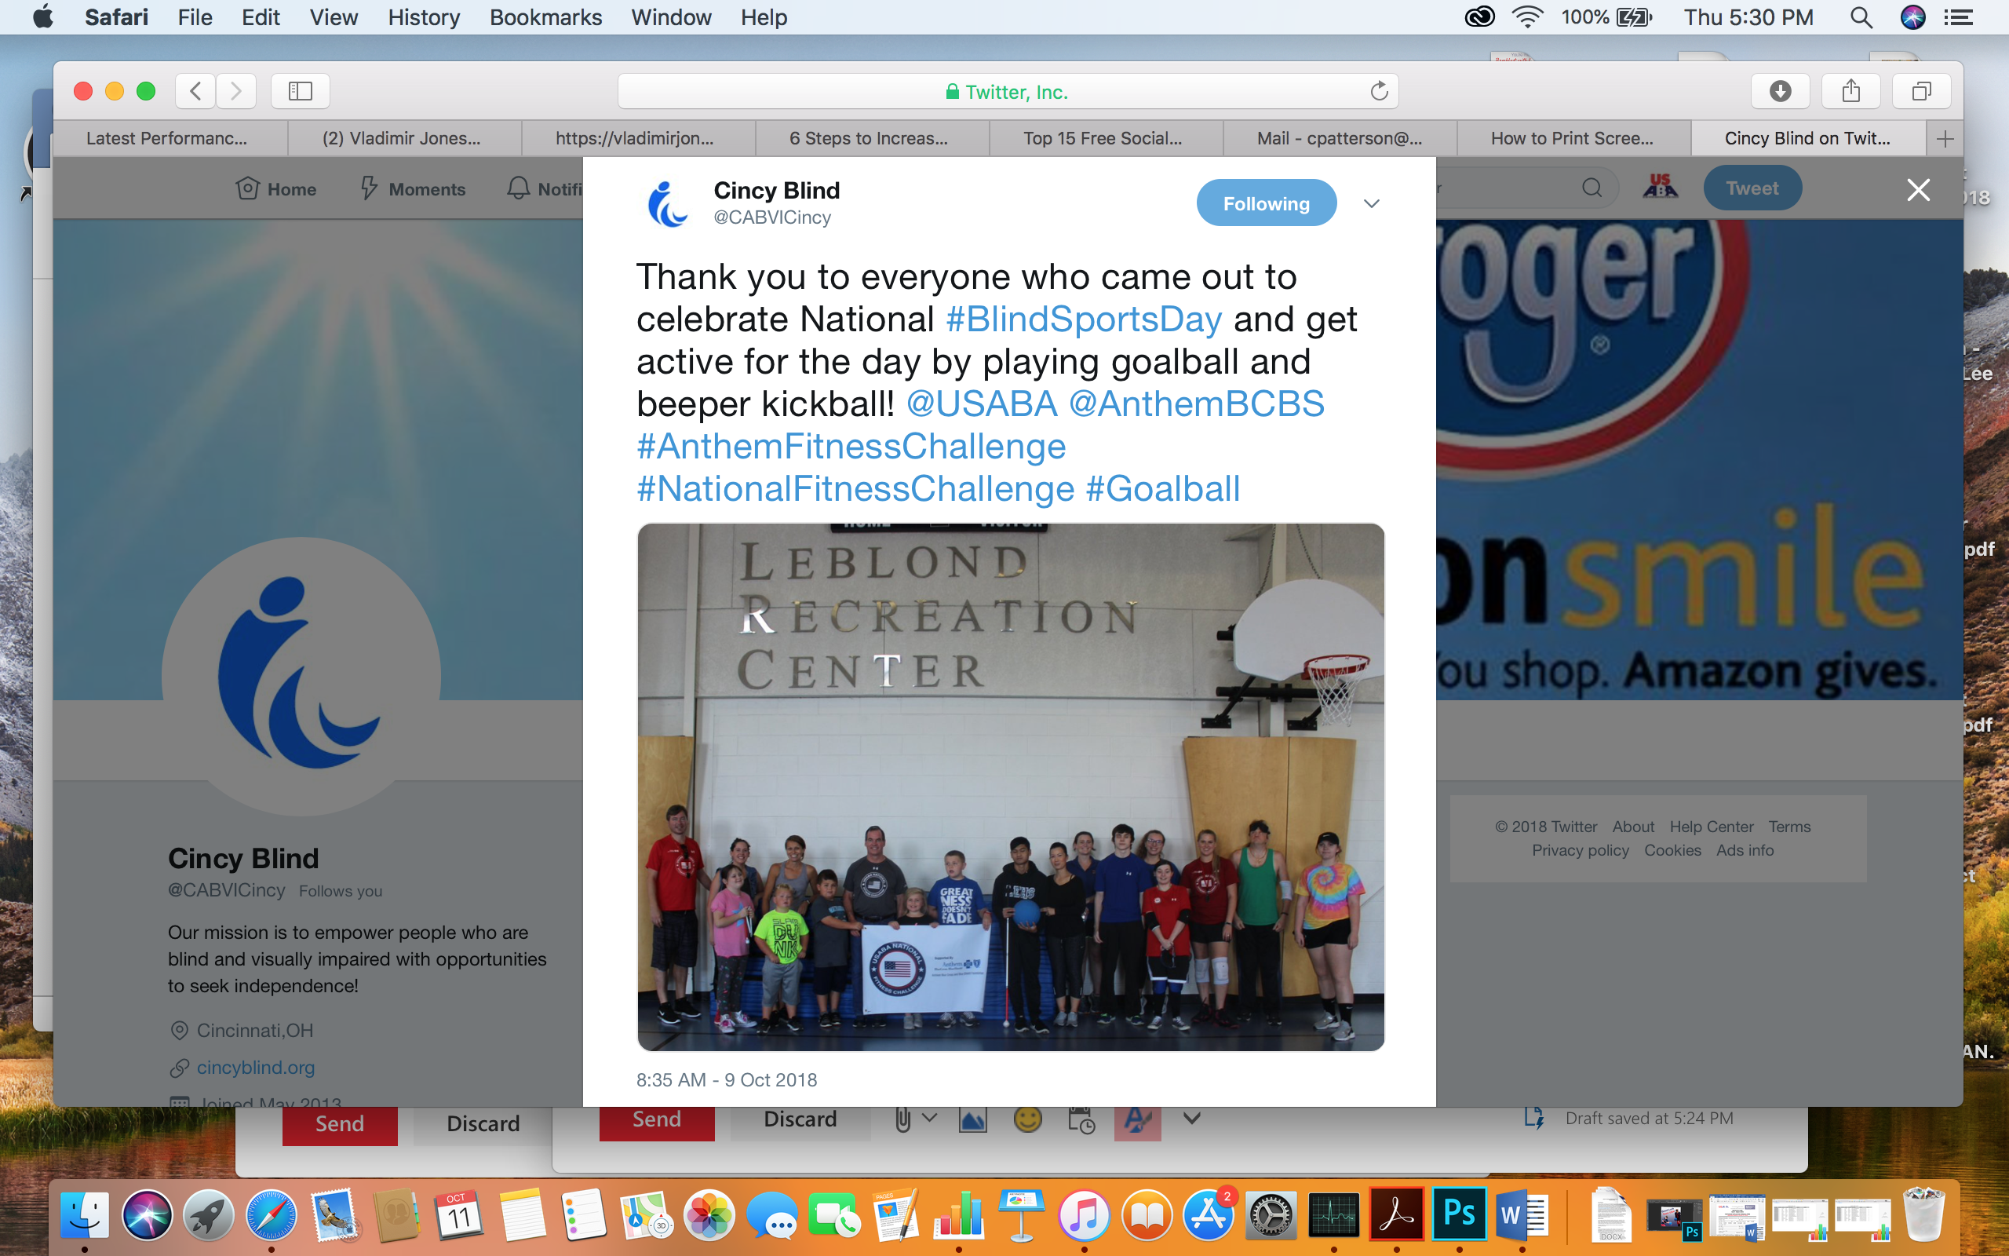](https://twitter.com/CABVICincy/status/1049669632884400128) [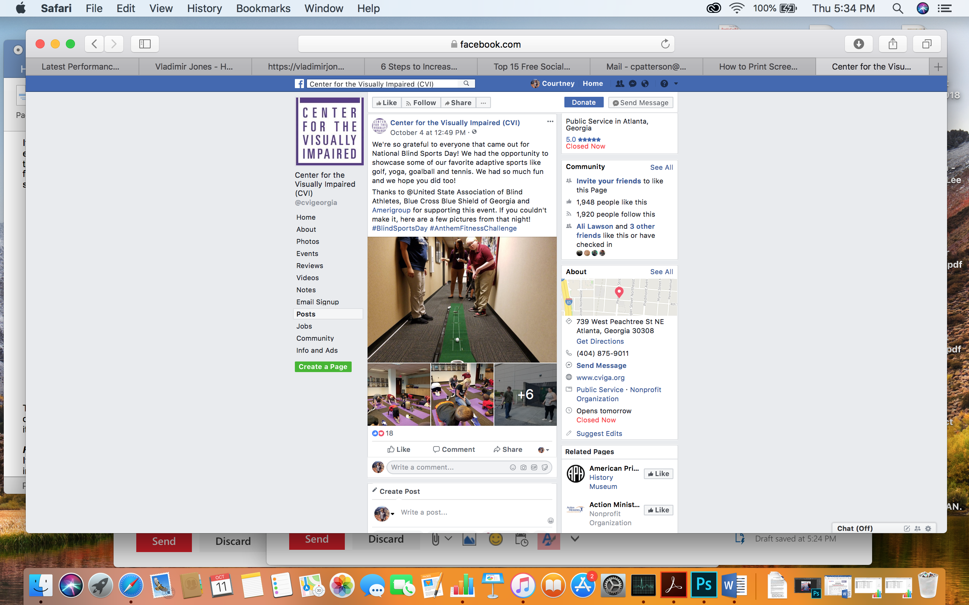](https://www.facebook.com/cvigeorgia/posts/2479071228800314?__xts__%5b0%5d=68.ARC82GJarlJHCEsrneAa-gH-DAcPd1bAiWgVacEtoxDp0PrBqEwuQmLrg_j5SkFppCpJyygwePz6_4k3hRke02m_zCS-v096I3vlv6bhzhIFD5Xqeo8Eye3UPemHv9HDD_BpEatwJ44rKQRq5Qj6x29yVtEmQ9u3LSNVAAgBXvSD1pfb0VNgOw&__tn__=-R)

Tip: Create Facebook events for NFC events and programming. It’s a way to get the word out to your followers about events you’re hosting and when someone RSVPs for an event, it pops up on their friends’ news feeds, extending the reach of your event!

***Facebook Group***

If you haven’t already, join the 2018-19 National Fitness Challenge Facebook group and invite your participants to join as well. The Facebook group is a digital space where participants and agencies across the country can communicate about the Challenge.

***Tag us!***

Very important! Please tag the appropriate pages and handles and use the hashtag #AnthemFitnessChallenge when promoting the NFC on social media. To receive impression credit USABA and the appropriate Anthem brand(s) must be used.

**Facebook:**

[United States Association of Blind Athletes](https://www.facebook.com/pages/United-States-Association-of-Blind-Athletes/115311768519523?sk=app_2309869772)

**and** YOUR REGION specific Anthem Brand (contact Tracy Kinoshita)

**Twitter:**

[@USABA](http://www.twitter.com/USABA)

**and** YOUR REGION specific Anthem Brand (contact Tracy Kinoshita)

If you don’t have a dedicated staff person in charge of your social media strategy, Tracy Kinoshita can help.

**USABA Writer**

We’ll be asking you for story ideas for a feature article on your organization’s participation in the National Fitness Challenge. The article will be published on USABA’s website and shared with you to promote as you wish. Keep this in mind throughout the program as we’ll reach out starting three months in for story ideas. Maybe there’s a participant showing great progress in increasing active minutes, or a sports program that’s really taken off in your community and is making a big impact.