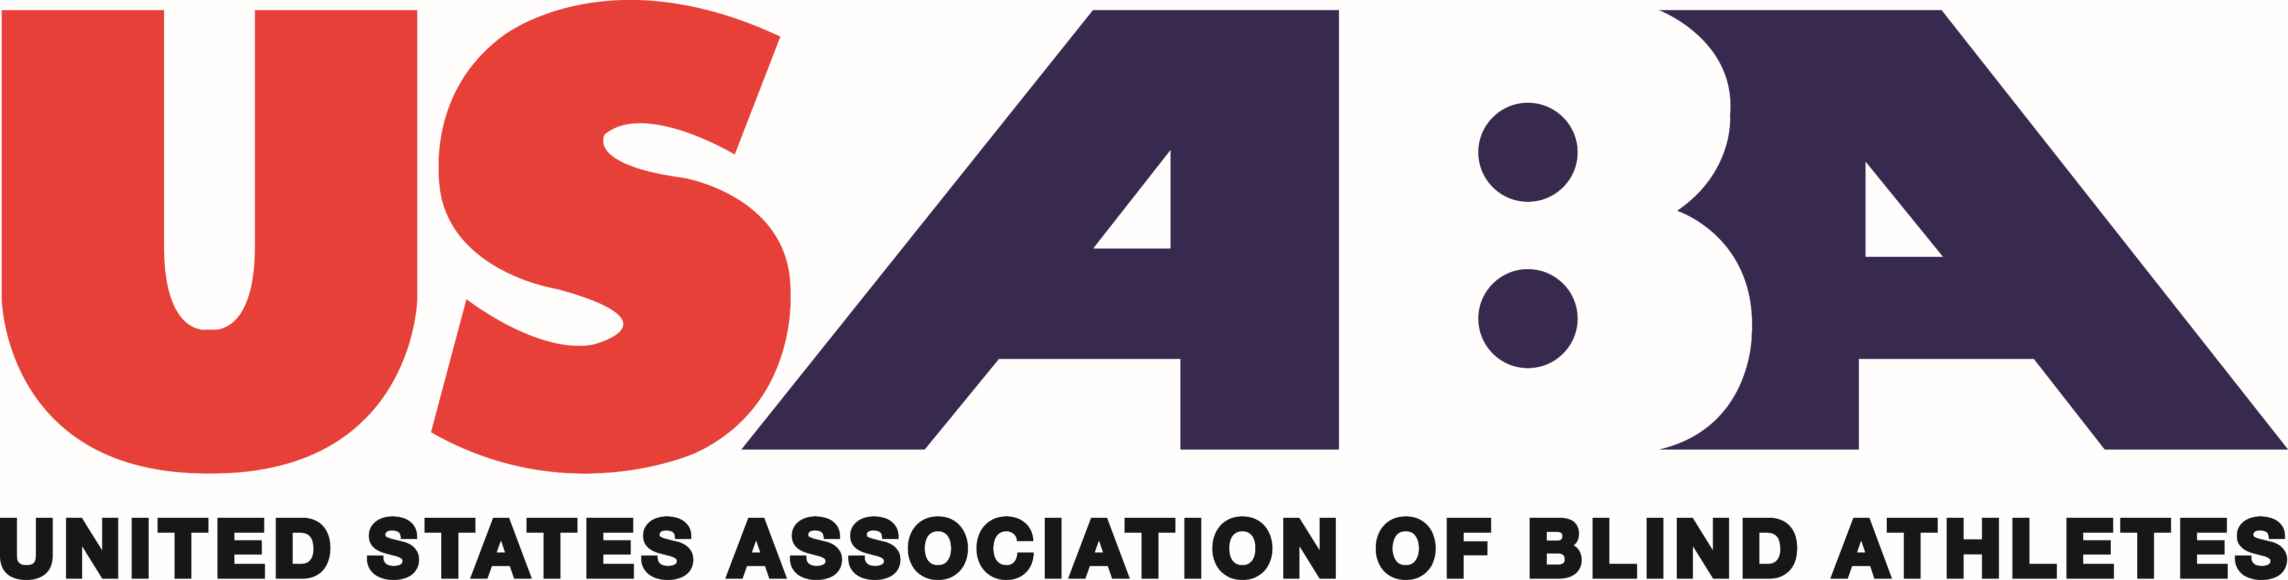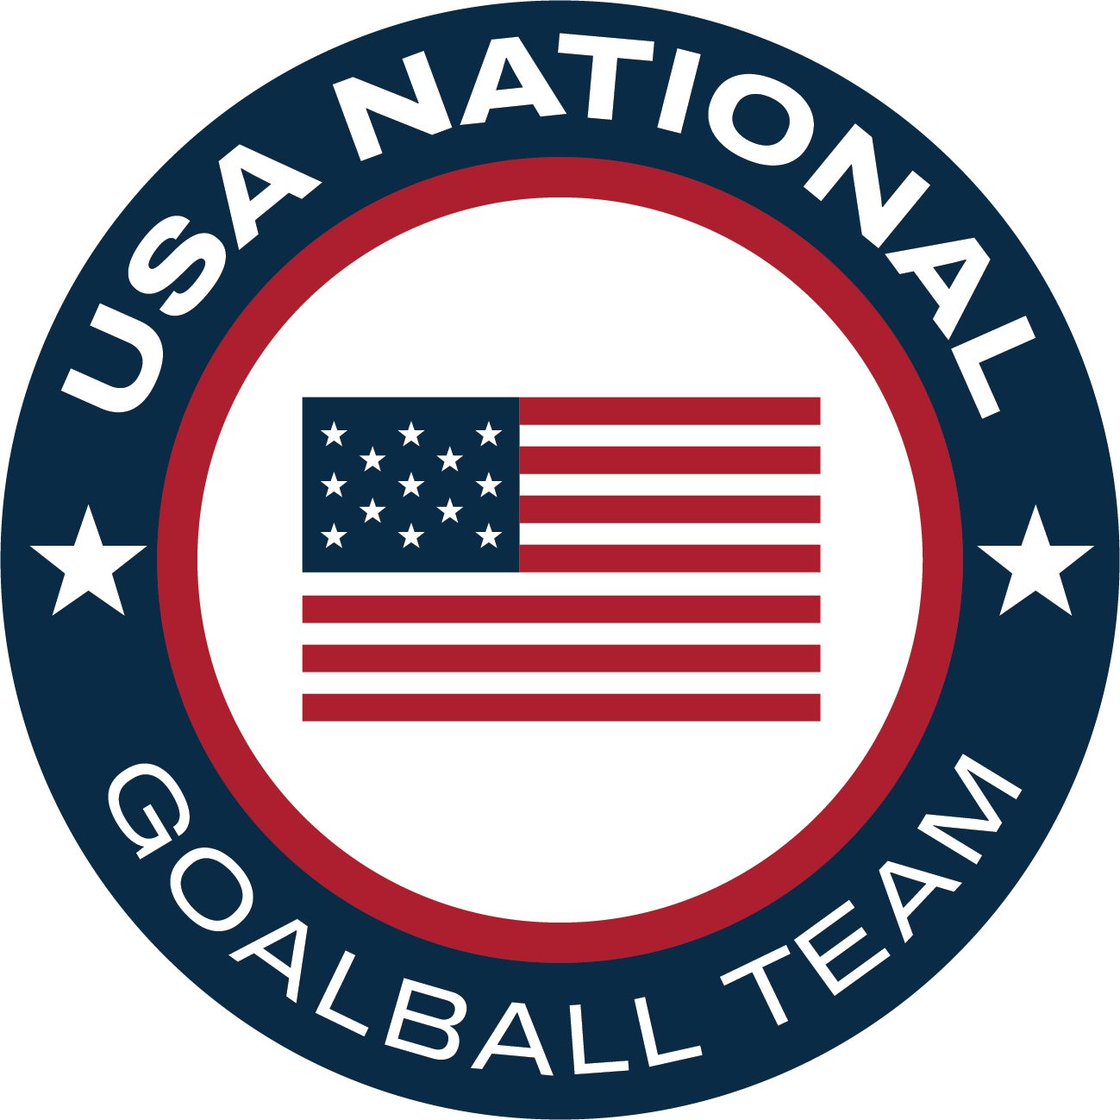

Goalball Club
HANDBOOK

Contact:
Kevin Brousard, Programs Manager
1 Olympic Plaza
Colorado Springs, CO 80909
Phone: (719) 866-3019
E-mail: kbrousard@usaba.org
Website: www.usaba.org

Table of Contents

CLUB INFORMATION & BENEFITS page 2
ELIGIBILITY REQUIRMENTS page 3
APPLICATION PROCESS & RECOMMENDATIONS FOR SUCCESS page 4
WHY SHOULD WE BECOME A CLUB? page 5
2022 GOALBALL CLUB APPLICATION pages 6-8
-GOALBALL CLUB APPLICATION page 6
-GOALBALL CLUB STATEMENT OF UNDERSTANDING page 7
-GOALBALL CLUB APPLICATION CHECKLIST page 8

WHAT IS A USABA GOALBALL CLUB?
USABA Goalball Clubs are non-profit organizations, state and local government agencies, athletic clubs, sports teams or any groups of USABA members who are interested in providing goalball opportunities for people who are blind and visually impaired in their community. These opportunities can be sport clinics, support for local athletes, regular sports practices or participation in regional and national USABA events and competitions. Any group that is interested in regular recreation or competition is eligible to become a member of USABA’s Goalball Club program and enjoy the benefits that come along with being part of Team USABA. We encourage groups that are not affiliated with an existing non-profit organization or agency to incorporate as a 501(c)(3) in order to achieve non-profit status; however, this is not a requirement for sports club membership.

USABA GOALBALL CLUB BENEFITS
- Access to liability insurance for Goalball Club events. In order to hold an event or practice at a third-party venue, liability insurance is a necessity for any Goalball Club. Becoming a USABA Goalball Club gives Goalball Clubs, small and large, access to use USABA’s liability insurance. This benefit alone will provide you the chance to grow your Goalball Club.
- Club/Event information for your Goalball Club shared on USABA website and social media. Let us help you spread the word about your Goalball Club through several different digital platforms. We are always looking to promote and highlight our athletes to our online community. Online exposure will bring a positive impact to your Goalball Club’s participation, fundraising and overall growth.
- Access to membership platform for club registration and tracking of memberships and safety requirements (Platform to be launched in 2022).
- Eligibility to apply for USABA support, which can include equipment grants, funding support and other programmatic assistance.
- Placement of your Goalball Club’s listing and web link on the USABA Sports Club section of our website.
- Opportunities to collaborate with other USABA Goalball Clubs nationwide through our USABA Sports Club distribution list.
- Access to USABA technical support.
- Opportunity to host Olympic/Paralympic Day Programs.
- Eligible to collaborate with USABA on securing programmatic funding through local sport and non-profit networks.
- Eligible through host USABA sanctioned events and clinics
- Receive exclusive USABA Sport’s Club email newsletter, which will include educational and training resources
- Eligible for designated USABA Board of Director and Committee roles

USABA GOALBALL CLUB ELIGIBILITY REQUIREMENTS
- USABA Goalball Club membership is open to community-based programs serving people who are blind and visually impaired, as well as any federal, state and private agencies.
- The annual Goalball Club membership fee is $200.00.
- The head of, or representative from, each Goalball Club must maintain their annual individual USABA membership or become a lifetime member.
- All participants including coaches, volunteers, and athletes must complete the
USABA Sports Club Event Waiver https://www.surveymonkey.com/r/28HTTN6 . Note: agreeing to the Event Waiver does not provide participants with USABA membership and its associated benefits.
- The head of, or representative from, each Goalball Club must pass the U.S. Center for Safe Sport Certification program. SafeSport certification is required for staff members, volunteers and guides/pilots who have direct supervision over athletes at an event insured under a USABA secondary insurance certificate.
- All staff members and coaches must submit an approved Background Check https://www.ncsisafe.com/Members/SelfRegBatchCode.aspx?srb=57781791
- Potential Goalball Club members must complete and submit the attached application.
- Along with your completed application, submit a roster of coaches, volunteers, athletes and others involved with your Goalball Club events. Include full name, phone number, email address and date of birth for each individual.
- All eligible Goalball Clubs in good standing are eligible for liability insurance for events and competitions at no cost. All certificate of insurance requests can be sent to Kevin Brousard (kbrousard@usaba.org). For USABA insured events, all event participants must complete the Event Waiver. Before a certificate is issued, the Goalball Club must send a participation list to Kevin Brousard (kbrousard@usaba.org) to verify current membership for event attendees. All participants must complete their USABA Event Waiver before the start of the event to comply with this policy. It is the responsibility of the sports club to strictly enforce this policy. By allowing individuals to participate in USABA insured Goalball Club events without agreeing to the waiver, Goalball Clubs will be in direct violation of the insurance certificate policy and will not receive insurance certificates for future events.
- It is the duty and responsibility of the individual Goalball Club to properly screen, train, supervise and confirm current and favorable background checks for all staff members, volunteers and guides/pilots who have direct supervision over athletes at an event insured under a USABA secondary insurance certificate.
- Goalball Club must agree to comply with the provisions of the USABA Sports Club guidelines found in this handbook and on the USABA Athlete Safety Policy.

USABA GOALBALL CLUB APPLICATION PROCESS
What do we need to do to become a USABA Goalball Club?
- Have Goalball Club leader sign up for USABA membership at https://www.usaba.org/join/
- Have your Goalball Club leader or representative and all key staff complete the SafeSport training course at https://www.ncsisafe.com/Members/SelfRegBatchCode.aspx?srb=57781791
- Complete background checks and SafeSport certification for any Goalball Club staff that will have direct supervision over athletes. It is the duty and responsibility of the individual Goalball Club to properly screen, train, supervise and confirm current and favorable background checks for all staff members, volunteers and guides/pilots who have direct supervision over athletes at an event insured under a USABA secondary insurance certificate.
- Complete and submit the Goalball Club Application, Staff & Athlete Roster.
- Read and sign the Statement of Understanding.
- Send all application documents to kbrousard@usaba.org
- $200 annual fee, which can be paid online here (put Goalball Club payment in comments). Checks can be mailed to the address below and made to USABA.
1 Olympic Plaza, Colorado Springs, CO 80909

RECOMMENDATIONS FOR SUCCESS
How do I make my USABA Goalball Club successful?
In addition to the Goalball Club affiliation guidelines found on our website, the following are recommendations that will help your USABA Goalball Club grow:
- Communicate with state and public schools, adapted physical education teachers, special education teachers, athletic directors, state physical education directors, state rehabilitation agencies, civic groups (local Lions Clubs) and interested volunteers to assist you in identifying and contacting individuals who are blind and visually impaired.
- List your organization in state and local resource guides (i.e., Chamber of Commerce, state directory for non-profit organizations and directory of agencies serving people with visual impairments).
- Plan, implement and promote regular programming for people who are blind and visually impaired.
- Work with USABA to identify local resources and potential partners to help you expand your programs and recruit new athletes, coaches and volunteers for your activities and events.

WHY SHOULD WE BECOME A USABA GOALBALL CLUB?
To encourage participation of athletes who are blind or visually impaired. As a USABA Goalball Club, you will have the opportunity to conduct nationally-recognized sporting events and encourage individuals to participate in life-enriching activities, including local, national and international athletic competitions.

To provide a direct link to local athletes who are blind or visually impaired and USABA members. As a USABA Goalball Club, you will receive important, up-to-date information that you can distribute to interested individuals regarding local, national and international programs and events.

To become a part of the movement to provide life-enriching athletic opportunities to every person in the United States with a visual impairment. Help USABA achieve our mission of reaching every person with a visual impairment in the United States to educate them about sport and recreation. Help us raise awareness about sports for individuals with visual impairments from the grassroots to the Paralympic level.

To connect with a national organization of clubs and athletes with interests similar to your own. USABA recognizes that the strength of our organization lies in its members. USABA Goalball Clubs are part of a nationwide organization that can come together to share ideas, collaborate on projects, and compete against one another on the field of play, which strengthens our overall ability to provide outstanding sports and recreational opportunities across the country. USABA Goalball Clubs can share information with us at any time for placement on our website, on social media platforms and in newsletters.

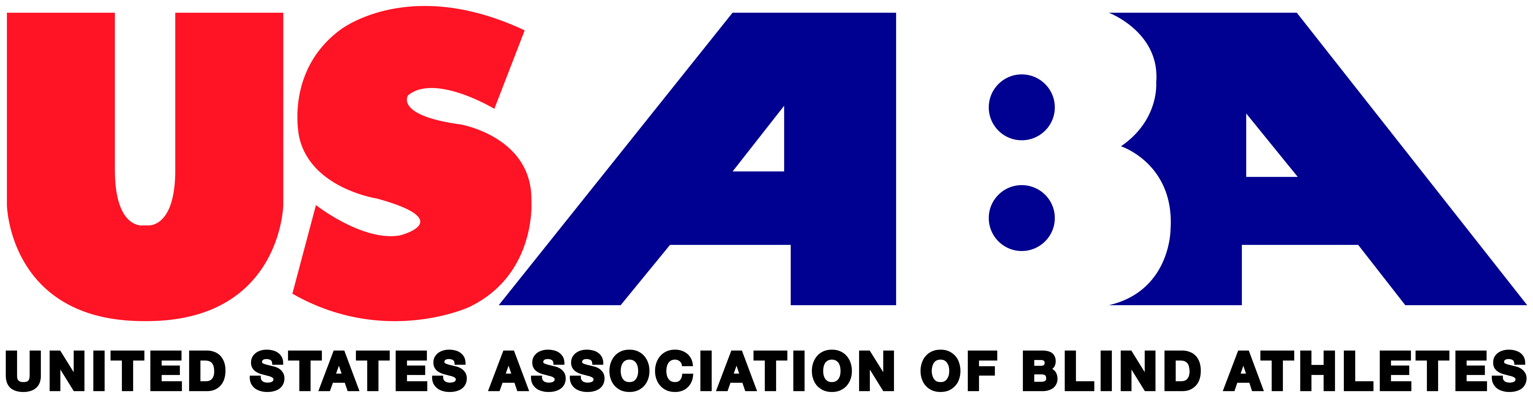

USABA GOALBALL CLUB APPLICATION

NAME OF ORGANIZATION: ________________________________________

STATUS: Federal Government Agency

State Government Agency

Community-Based Organization Serving the Blind

Private Agency Serving the Blind

Other (please state)

SIZE OF ORGANIZATION (number of members): ____________________________

STREET: ____________________________

CITY: _____________________________ STATE: ________ ZIP: _________

PHONE: ___________________________ EMAIL: _____________________

WEB ADDRESS: ____________________________________________

FACEBOOK PAGE: __________________________________________

TWITTER HANDLE: _________________________________________

NAME OF ORGANIZATION CONTACT PERSON: ______________________________

TITLE: ________________________________________

CONTACT INFORMATION (IF DIFFERENT FROM ABOVE):

UNITED STATES ASSOCIATION OF BLIND ATHLETES (USABA)
STATEMENT OF UNDERSTANDING - USABA GOALBALL CLUB
NOTE: This statement of understanding must be reviewed and agreed upon on an annual basis as a condition to becoming and maintaining a USABA Goalball Club membership. By signing the membership form and this statement, the organization becoming a USABA Goalball Club member affirms having understood all terms and conditions.

In consideration of my involvement under the auspices of USABA as a USABA Goalball Club, our organization acknowledges and agrees to the following:

- The information contained on our application is factual and current;
- We agree to inform USABA immediately upon any changes to the status of our USABA Goalball Club or contact information;
- We agree to comply with all aspects of the USABA Goalball Club Handbook;
- We hold harmless and promise not to sue the United States Association of Blind Athletes, their officers, officials, agents and/or employees, with respect to any such injury, molestation, paralysis, dismemberment, death and/or loss or damage to property except that which is the result of gross negligence and/or wanton misconduct that may occur at an event our USABA Goalball Club may conduct;
- We ensure that all participants at USABA insured Goalball Club events have completed the Event Waiver;
- We agree to take full responsibility to properly screen, train, supervise and confirm current and favorable background checks and US Center for Sport Training for all staff members, volunteers and guides/pilots who have direct supervision over athletes at an event insured under a USABA secondary insurance certificate;
- We agree not to use the names United States Association of Blind Athletes, United States Association of Blind Athletes Goalball Club, USABA or USABA Goalball Club in illegal, unethical or subversive activities or in any manner that would bring negative attention to the United States Association of Blind Athletes or any other United States Association of Blind Athletes Goalball Club;
- We will maintain proper liability insurance for any activities we conduct and, upon request, we understand insurance may be available through the United States Association of Blind Athletes;
- We will help to strengthen USABA by providing names and email addresses of any participants in programs conducted with a certificate of insurance from USABA;
- We understand that the risk of bodily injury, including paralysis, dismemberment and death as well as loss or damage to property could be an outcome in any event or program we conduct using the USABA Goalball Club name;
- We knowingly and freely assume all such risk;

__________________________________ __________________________________
Printed Name Title
__________________________________ __________________________________
Signature Date

USABA GOALBALL CLUB APPLICATION CHECKLIST
- Have all participants complete the Event Waiver: https://www.surveymonkey.com/r/28HTTN6
- Have your Goalball Club leader or representative and all key staff complete the SafeSport training course at www.safesport.org.
- Complete background checks and SafeSport certification for any Goalball Club staff that will have direct supervision over athletes under the age of 18. It is the duty and responsibility of the individual Goalball Club to properly screen, train, supervise and confirm current and favorable background checks for all staff members, volunteers and guides/pilots who have direct supervision over athletes under the age of 18 at an event insured under a USABA secondary insurance certificate.
- Complete the Goalball Club Application.
- Read and sign the Statement of Understanding.
- Complete Staff and Athlete Roster Sheet.
- Submit $200 annual payment

Send completed Application, Statement of Understanding, and Staff and Athlete Rosters to Kevin Brousard (kbrousard@usaba.org) or by mail to:

USABA
1 Olympic Plaza
Colorado Springs, CO.
80909

