Campus Recreation
Sport Clubs
Spectator Guide

Welcome
Our goal is to provide every individual with the best experience possible while visiting our campus. In this guide, you will find important information regarding Towson University policies along with information regarding food establishments, lodging information and parking. We hope you enjoy your experience here at Towson University!

Facilities

Burdick Field
Burdick Field is located in the center of campus, adjacent to Burdick Hall and the University Union. The complex will host all field sport events. Restrooms are available in the University Union, Burdick Hall and within the Schuerholz Park Baseball facility.

Burdick Hall
Burdick Hall contains three (3) basketball courts and two (2) multi-activity courts, which serve as the locations for all indoor sporting contests. All spectators will be required to sign an attendance log. Both players and spectators may be required to obtain a hand stamp to ensure future access into the facility. Under no circumstances should a spectator participate in any activities. Spectator seating in the courts is extremely limited.

Important Guidelines

General Guidelines
- All visiting teams are required to adhere to all federal, state, and University laws, guidelines, standards and policies.
- Please follow posted parking regulations. Campus Recreation is not responsible parking fines.
- Respect and follow the directive of all Campus Recreation staff.
- Practice good sportsmanship and act in a positive, mature and responsible manner.
- Unless otherwise approved by the Assistant Director for Competitive Sports, tailgating is not permitted. Grills are not permitted to be used in parking garages.
- Alcohol may not be consumed in Campus Recreation facilities and open-containers are not permitted on-campus.
- Please use the trash and recycling receptacles provided.
- Towson University is a smoke free campus.
- No pets. Service animals are permitted in Campus Recreation facilities; comfort animals are not permitted as per University policy.

Burdick Field Guidelines
- Access to the complex is limited to available gates.
- Purposely hitting, kicking and throwing balls into the fence or divider net is strictly prohibited.
- Tents must be weighted with sandbags or weighted buckets. No staking!
- Tables, chairs, coolers, and other equipment are subject to inspection at any time.
- Unless otherwise approved by the Assistant Director, posting of signs, fliers, posters and other announcements is not permitted.
- The following items are prohibited inside the fence line of Burdick Field:
  - FOOD & BEVERAGE
    - All food products including gum
    - All beverages other than water
    - Water must be in a non-glass, non-spillable bottle
  - FOOTWEAR
    - Metal cleats or pointed heels
  - EQUIPMENT
    - Skateboards, roller blades, bicycles, scooters, and other wheeled apparatuses
    - Golfing equipment, inflatables, trampolines
    - Stakes, spikes, or other pointed objects
    - Grills, space heaters, or other equipment with open flames or powered by fuel
    - Unapproved vehicles
  - OTHER
    - Alcohol, illegal drugs and tobacco products
    - Paint, tape, loose chalk, and other adhesive materials

Burdick Hall Guidelines
- All spectators must check-in at the Welcome Desk
- Under no circumstances should a spectator participate in any activities such as playing basketball or using fitness equipment.
- Spectator space is very limited within Burdick Hall. Chairs are not provided to spectators.
- Congregating in the hallways is not allowed. Please keep hallways clear.
- For the privacy and convenience of members and guests, video recording or photography of any kind, including video messaging, is not permitted outside of club practice locations and events.
- Posting of signs, fliers, posters and other announcements is not permitted.
- Kicking, throwing, or striking equipment towards the wall, ceiling, basketball assembly, or mezzanine/balcony is prohibited.
- No leaning or sitting against the curtain divider at any time.
- Spectating is not allowed from the upper level windows on the Fitness Floor into the MAC’s.
- The following items are prohibited inside the Burdick Hall activity spaces:
  - FOOD AND BEVERAGE:
    - All food products including gum
    - All drinks must be in a non-glass, non-spillable bottle
  - FOOTWEAR: Cleats
  - EQUIPMENT:
    - Skateboards, roller blades, bicycles, scooters, and other wheeled apparatuses
    - Golfing equipment
    - Stakes, spikes, or other pointed objects
    - Grills, space heaters, or other equipment with open flames or powered by gas
  - OTHER:
    - Alcohol, illegal drugs and tobacco products
    - Paint, tape, loose chalk, and other adhesive materials

Rec Responsibly
Campus Recreation users, visitors, participants and affiliates are expected to Rec Responsibly. Rec Responsibly means…
- To utilize recreation resources to better ones personal health and well-being
- To be proactive about safety and manage risk
- To treat yourself, others, and the space you are utilizing with the utmost respect and consideration
- To be accountable for one’s personal behavior and interaction with others
- To create a welcoming and inclusive environment for all

Directions to Towson University
From I-95 (northbound and southbound): Take the Baltimore Beltway I-695 west (toward Towson). Take exit 25 (Charles Street) south. Proceed 1.7 miles. Turn left on Towsontown Boulevard and proceed to the second traffic light on Osler Drive. Follow the campus signs or refer to the campus map for information about your specific destination.

From I-83 (northbound and southbound): Take the Baltimore Beltway I-695 east (toward Towson). Take exit 25 (Charles Street) south. Proceed 1.7 miles. Turn left on Towsontown Boulevard and proceed to the second traffic light on Osler Drive. Follow the campus signs or refer to the campus map for information about your specific destination.

From I-70 (eastbound): Take the Baltimore Beltway I-695 north (toward Towson). Take exit 25 (Charles Street) south. Proceed 1.7 miles. Turn left on Towsontown Boulevard and proceed to the second traffic light on Osler Drive. Follow the campus signs or refer to the campus map for information about your specific destination.

From Baltimore (Penn Station): Proceed north on Charles Street for five miles. Turn right on Towsontown Boulevard and proceed to the second traffic light on Osler Drive. Follow the campus signs or refer to the campus map for information about your specific destinations.

Interactive Map
Spectators are encouraged to use the TU Sport Clubs Interactive Map. The interactive map, hosted by Google, provides locations for on and off campus athletic facilities, parking, and area amenities such as medical facilities, food, lodging, shopping, transportation and attractions. In some cases, additional information is provided such as contacts for local hotels, restaurants, medical facilities and even parking regulations. Driving directions can also be provided to any of the locations on the map. Whether you are on-site or just planning your trip, this tool will come in handy!

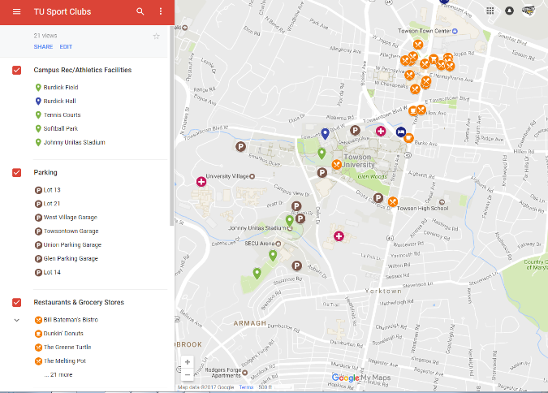

Area Amenities (Lodging, Restaurants, Etc.)
Information on area lodging, restaurants, etc. can be found within the TU Sport Clubs Interactive Map. In addition, the University maintains a list of accommodation options online. On campus dining options are outlined here.

Local Attractions

Baltimore
Only 11 miles from the university, Baltimore has something for everyone. Built around the inner harbor, the city is a walker's delight, with a lineup of attractions within three or four blocks of one other. More information can be found at www.baltimore.org.

Annapolis
Annapolis boasts historic charm with its beautifully preserved and restored buildings and brick downtown streets. A boater's paradise, the city ranks as the Sailing Capital of America and hosts the country's largest in-water boat show every October. More information can be found at www.visit-annapolis.org.

Washington, DC
Just an hour drive away, Washington, DC, is a metropolitan city with historic attractions, museums, monuments, hotels, restaurants, free annual events, and visitor services unrivaled by any other American city. Since the capital is only nine miles from the university, and accessible by Metrorail from College Park, a visit to the city is convenient. More information can be found at www.washington.org.

Important Links
- Towson University Visitors Guide
- Campus Map
- Parking & Transportation Services
- Campus Recreation Website
- TU Sport Clubs Facebook Page
- TU Sport Clubs Twitter Feed

