Campus Recreation
Sport Clubs
Visiting Team Packet

Welcome
Our goal is to provide every individual with the best experience possible while visiting our campus. In this packet, you will find important information for your upcoming event at Towson University. Please share this information with your teammates and potential spectators so that we can assure a safe, fun experience.

Facilities

Burdick Hall
Burdick Hall contains three (3) basketball courts and two (2) multi-activity courts, which serve as the locations for all indoor sporting contests. While participating in a Sport Club contest in Burdick Hall, visiting teams will not be allowed to utilize the facility in any capacity other than their specific sport club related activity. Auxiliary services such as bathrooms and locker rooms will be available for use. All spectators will be required to sign an attendance log. Both players and spectators may be required to obtain a hand stamp to ensure future access into the facility. Under no circumstances should a spectator participate in any activities. Spectator seating in the courts is extremely limited. Accommodations for spectators should be discussed with the hosting club prior to the event.

Burdick Turf Field
Burdick Turf Field is located in the center of campus, adjacent to Burdick Hall and the University Union. The complex will host all field sport events. Under no circumstances should any spectator participate in any activities. Accommodations for spectators should be discussed with the hosting club prior to the event. Restrooms are available in the University Union, Burdick Hall and within the Schuerholz Park Baseball facility.

Important Guidelines

Alcohol and Tailgating Guidelines
Unless otherwise approved by the Assistant Director for Competitive Sports, tailgating is not permitted. Alcohol may not be consumed in Campus Recreation facilities and open-containers are not permitted on-campus. Grills are not permitted to be used in parking garages.

Cleats
Cleats are not permitted in the University Union, Burdick Hall or any Towson University building. You must take off cleats before entering any building.

Apparel
Facility users must be fully clothed at all times including shirts, shorts/pants, and appropriate footwear. Appropriate and non-damaging attire is requested at all times in accordance with the Campus Recreation Apparel Guidelines.

Pets/Service Animals
No pets. Service animals are permitted in Campus Recreation facilities; comfort animals are not permitted as per University policy.

Burdick Field Guidelines
- Purposely hitting, kicking and throwing balls into the fence or divider net is strictly prohibited.
- The playing of projected music or use of stereo systems is prohibited unless approved by Campus Recreation staff.
- Tents must be weighted with sandbags or weighted buckets. No staking!
- Tables, chairs, coolers, and other equipment are subject to inspection at any time.
- Unless otherwise approved by the Assistant Director, posting of signs, fliers, posters and other announcements is not permitted.
- The following items are prohibited inside the fence line of Burdick Field:
  - FOOD & BEVERAGE
    - All food products including gum
    - All beverages other than water
    - Water must be in a non-glass, non-spillable bottle
  - FOOTWEAR
    - Metal cleats or pointed heels
  - EQUIPMENT
    - Skateboards, roller blades, bicycles, scooters, and other wheeled apparatuses
    - Golfing equipment, inflatables, trampolines
    - Stakes, spikes, or other pointed objects
    - Grills, space heaters, or other equipment with open flames or powered by fuel
    - Unapproved vehicles
  - OTHER
    - Alcohol, illegal drugs and tobacco products
    - Paint, tape, loose chalk, and other adhesive materials

Burdick Hall Guidelines
- Congregating in the hallways is not allowed. Please keep hallways clear.
- For the privacy and convenience of members and guests, video recording or photography of any kind, including video messaging, is not permitted outside of club event locations.
- Non-marking, soft-soled, closed-toe and heel athletic shoes are required.
- Posting of signs, fliers, posters and other announcements is not permitted.
- Kicking, throwing, or striking equipment towards the wall, ceiling, basketball assembly, or mezzanine/balcony is prohibited.
- No not try to retrieve stuck balls from the rafters. Contact a Facility Manager. Stuck balls will be retrieved by facility staff during winter, spring or summer break.
- The playing of projected music or use of stereo systems is prohibited in Gym 1 unless approved for a reservation or needed for a specific sport activity. Music is allowed in Gym 3.
- Hanging or climbing on the net, rim, or any part of basketball standards is prohibited.
- No leaning or sitting against the curtain divider at any time.
- The following items are prohibited inside the Burdick Hall activity spaces:
  - FOOD AND BEVERAGE:
    - All food products including gum
    - All drinks must be in a non-glass, non-spillable bottle
  - FOOTWEAR: Cleats
  - EQUIPMENT:
    - Skateboards, roller blades, bicycles, scooters, and other wheeled apparatuses
    - Golfing equipment
    - Stakes, spikes, or other pointed objects
    - Grills, space heaters, or other equipment with open flames or powered by gas
  - OTHER:
    - Alcohol, illegal drugs and tobacco products
    - Paint, tape, loose chalk, and other adhesive materials

Rec Responsibly
Campus Recreation users, visitors, participants and affiliates are expected to Rec Responsibly. Rec Responsibly means…
- To utilize recreation resources to better ones personal health and well-being
- To be proactive about safety and manage risk
- To treat yourself, others, and the space you are utilizing with the utmost respect and consideration
- To be accountable for one’s personal behavior and interaction with others
- To create a welcoming and inclusive environment for all

Athletic Trainers
In most cases, one Athletic Trainer will be present at all Towson University Sport Clubs Home Events. All Athletic Trainers will bring a basic kit with them to any event they may cover. All visiting teams should provide their own basic first aid supplies. Athletic Trainers will not be expected to provide tape for taping any chronic injuries. If a player would like to be taped, the player and/or team will need to provide the Athletic Trainer with the tape.

Waivers
All visiting/guest players are required to complete a GUEST AGREEMENT, WAIVER, HOLD HARMLESS AND COVENANT NOT TO SUE (waiver) prior to participating in any activity in any Campus Recreation facility. Please make copies for your team prior to competition (see Appendix) and have them completed prior to arrival. A Coach/Officer Waiver Verification Form must also be completed prior to the event and submitted along with all guest waivers.

Spectator Guide
All visiting teams are expected to share the Towson University Sport Clubs Spectator Guide with anyone who may be coming to watch you compete, such as family and friends.

Spectator space is very limited within Burdick Hall. Chairs are not provided to spectators and spectating is not allowed from the upper level windows on the Fitness Floor into the MAC’s.

Directions & Parking

Directions
From I-95 (northbound and southbound): Take the Baltimore Beltway I-695 west (toward Towson). Take exit 25 (Charles Street) south. Proceed 1.7 miles. Turn left on Towsontown Boulevard and proceed to the second traffic light on Osler Drive. Follow the campus signs or refer to the campus map for information about your specific destination.

From I-83 (northbound and southbound): Take the Baltimore Beltway I-695 east (toward Towson). Take exit 25 (Charles Street) south. Proceed 1.7 miles. Turn left on Towsontown Boulevard and proceed to the second traffic light on Osler Drive. Follow the campus signs or refer to the campus map for information about your specific destination.

From I-70 (eastbound): Take the Baltimore Beltway I-695 north (toward Towson). Take exit 25 (Charles Street) south. Proceed 1.7 miles. Turn left on Towsontown Boulevard and proceed to the second traffic light on Osler Drive. Follow the campus signs or refer to the campus map for information about your specific destination.

From Baltimore (Penn Station): Proceed north on Charles Street for five miles. Turn right on Towsontown Boulevard and proceed to the second traffic light on Osler Drive. Follow the campus signs or refer to the campus map for information about your specific destinations.

Parking Locations
The designated location to park for Sport Club events is the Towsontown Parking Garage. Please refer to the TU Sport Clubs Interactive Map for a visual of the parking location.

Fees and Permits
Vehicles parked on campus must display a valid permit or be parked at a paid meter Monday through Thursday from 6 a.m. to 8 p.m. and Friday 6 a.m. to 3 p.m. Permits are not required in most locations from 3 p.m. Friday to 6 a.m. Monday or when the University is officially closed for a holiday or inclement weather. We will NOT reimburse any parking tickets.

If you will be traveling to campus using a charted service (Bus, Shuttle, etc.), please contact Jeff Keenan (jkeenan@towson.edu), prior to arrival on campus. We will arrange parking accommodations.

Interactive Map
Visiting teams are encouraged to use the TU Sport Clubs Interactive Map. The interactive map, hosted by Google, provides locations for on and off campus athletic facilities, parking, and area amenities such as medical facilities, food, lodging, shopping, transportation and attractions. In some cases, additional information is provided such as contacts for local hotels, restaurants, medical facilities and even parking regulations. Driving directions can also be provided to any of the locations on the map. Whether you are on-site or just planning your trip, this tool will come in handy!

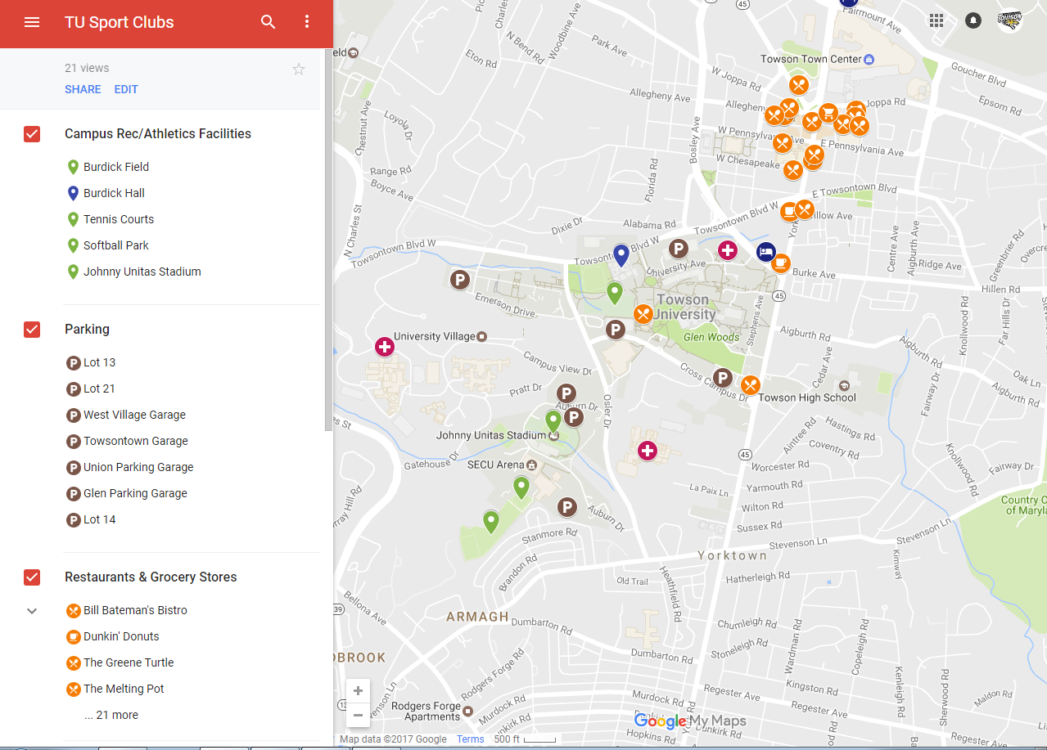

Area Amenities (Lodging, Restaurants, Etc.)
Information on area lodging, restaurants, etc. can be found within the TU Sport Clubs Interactive Map. In addition, the University maintains a list of accommodation options online. On campus dining options are outlined here.

Payment
The use of registration/entry fees will be up to the discretion of the individual club hosting the event. In this instance, the individual club should provide an invoice for said fee. Payments must be made in the form of a check. Checks should be made out to “Towson University” and indicate the specific club in the memo section. All checks should be sent to the following address:

Jeff Keenan (Club Name)
Towson University-Campus Recreation
8000 York Road
Towson, MD 21252

Tax identification information (W9) is available upon request. Please contact Jeff Keenan, jkeenan@towson.edu, if you need to obtain this information.

Important Links
- Towson University Visitors Guide
- Campus Map
- Parking & Transportation Services
- Campus Recreation Website
- TU Sport Clubs Facebook Page
- TU Sport Clubs Twitter Feed

REQUIRED FORMS: NEXT PAGES

COACH /OFFICER WAIVER VERIFICATION FORM

This form must be filled out by a coach or an officer and is due to the Campus Recreation Operations Supervisor prior to play. Turn in this form with all guest waivers.

Number of Waivers Collected: _________

I, __________________________________, certify that each player has submitted a completed guest waiver. To the best of my knowledge, all information provided is accurate.

Signature: ____________________________ Date: ____________________________

Position: _____________________________________________________
EX: Coach, President, Captain

School/Visiting Team: __________________________________________
EX: University of Maryland

Sport: _______________________________________________________
EX: Men’s Rugby
Email: _______________________________________________________
Phone Number: _______________________________________________

TOWSON UNIVERSITY CAMPUS RECREATION
GUEST AGREEMENT, WAIVER, HOLD HARMLESS AND COVENANT NOT TO SUE

Name (printed): _____________________________

Sport Club_________________________________________________ Date(s) of Event___________________________

Notice: This Agreement is a contract with legal consequences. Read it carefully before signing!
In consideration of my use of the Campus Recreation facilities as a guest, I hereby freely agree to make the following contractual representations and agreements:

I fully realize the dangers of using the facilities at Campus Recreation and voluntarily assume all risks associated. I understand the risks include, by way of example, and not limitation, the following: Accidents may happen while traveling and walking to Campus Recreation facilities. Injuries can occur due to falls, equipment failure, other participants, over exertion, and adverse weather conditions. Injuries could result in concussion, broken bones, torn muscles or tendons, welts or scrapes, psychological harm, hospitalization or death.
I agree that it is my sole responsibility to be familiar with the physical and/or mental demands associated with the above named events. With these demands in mind, I have no physical or mental condition, which to my knowledge, would endanger myself or others if I participate in this event, or would interfere with my ability to participate in the event. I also agree to abide by any established rules or regulations while engaged in this activity, and with the directions and precautions given by leaders and/or instructors.
I understand that Towson University has no duty to provide any extraordinary duties or safety measures in relation to this activity and that I must use reason and judgment in my undertakings hereunder. I consent to Towson University providing emergency health assistance if it is determined necessary in its discretion, and consent to Towson University contacting my emergency contact for notification.
I understand and expressly assume all the risks and dangers of the activities contemplated by this Agreement, and I hereby release, waive, discharge, and covenant not to sue Towson University, the University System of Maryland, the State of Maryland, and their officers, agents, servants, and employees (collectively, the “Releasees”) from all liability, claims, demands, actions, or causes of action whatsoever arising out of any damages, loss, or injury to me or to my property while participating in any of the activities contemplated by this Agreement, whether such damage, loss, or injury results from the negligence of the Releasees or from any other cause. I also hereby release, waive, discharge and covenant not to sue the Releasees from any claims whatsoever on account of any first aid, treatment, or service rendered to me during my participation in the above activity. I hereby agree to indemnify and hold harmless the Releasees from any loss, liability, damage, or costs, including court costs and attorneys’ fees, that they may incur due to my participation in said activities, whether caused by the negligence of Releasees or otherwise.
I agree, for myself and my successors, that the above representations and agreements are contractually binding, and are not mere recitals. I agree that my failure or refusal to sign such agreements or releases shall in no way affect the validity of this Agreement, nor revoke or cancel any of the terms of this Agreement. I or any of my successors shall be liable for the expenses (including legal fees) incurred by the party or parties in defending against such claim or suit. This Agreement shall not be modified orally.

I hereby certify that I have Health Insurance. My insurance company is:

I have carefully read this form and fully understand its contents. All information I have provided is true. I am aware that this is a release of liability, a waiver of claims, an agreement not to sue, an indemnity, and a contract between myself and Towson University and for the benefit of others described herein, I sign it of my own free will.

PARENT OR GUARDIAN OF A MINOR: I, as parent or guardian of the above named minor, hereby give my permission for my child or ward to participate in the above named activity, and further agree, individually and on behalf of my child or ward, to the terms of the above.

Participant Email:___________________________________ Participant Phone:____________________________________________

Participant’s Signature:______________________________________________________ Date:_______________________________

Parent’s or guardian’s signature if participant is under 18:__________________________________ Date:_____________________

Emergency Contact Information:
Name:_______________________________________ Phone Number:_____________________ Relationship:_____________________

